- Press F2 while booting up to enter BIOS Setup, modify ‘Secure Boot’ to ‘Disabled’, save modification and reboot.

- Open Test Mode：
Open CMD as administrators，input ‘bcdedit /set testsigning on’ and then reboot.

- Copy the BIOS tool file to IdeaPad 4G/5G desk, open the file and open CMD as administrators under this path.

- Read SMBIOS.CFG. Input below commands in CMD:
QCFactoryTool.exe /RawFS SMBIOS GetFileData SMBIOS\SMBIOS.CFG SMBIOS.CFG 0
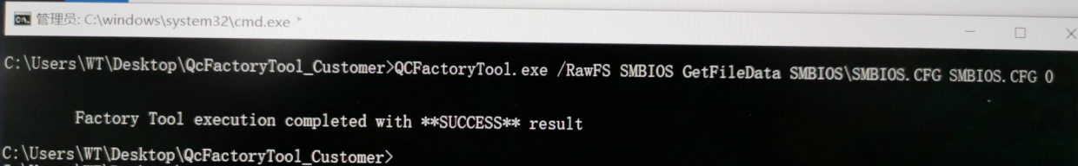

- Modify fields in SMBIOS.CFG. Open SMBIOS.CFG under txt format, find the fields need modify, for example Product Name: write,pn, "INVALID", modify string in double quotation marks and save the change.
Note: there must be string in double quotation marks, don’t modify to write,pn,""

- Write SMBIOS.CFG. Input below commands in CMD:
QCFactoryTool.exe /SMBIOS SMBIOS.CFG
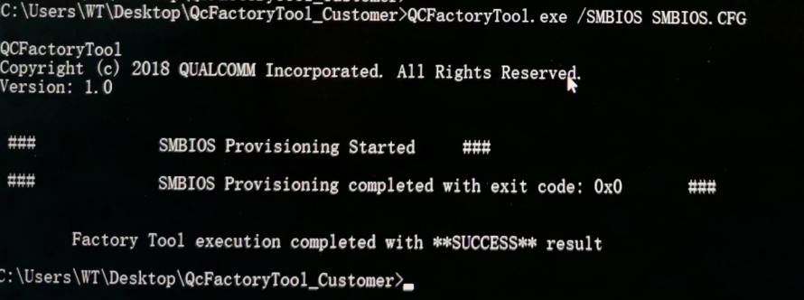

7.Reboot.

